JOINS QURIES WITH VIEWS

/* COMPLETE CITIZEN PROFILE REPORT*/
CREATE VIEW Person_Detail_View AS
SELECT
p.person_id,
p.first_name,
p.last_name,
bs.sex_name,
el.level_name,
es.status_name AS employment_status,
ms.status_name AS marital_status,
n.country_name,
h.household_size
FROM Person p

INNER JOIN Biological_Sex bs
ON p.sex_id = bs.sex_id

INNER JOIN Education_Level el
ON p.education_level_id = el.education_level_id

INNER JOIN Employment_Status es
ON p.employment_status_id = es.employment_status_id

INNER JOIN Marital_Status ms
ON p.marital_status_id = ms.marital_status_id

INNER JOIN Nationality n
ON p.nationality_id = n.nationality_id

INNER JOIN Household h
ON p.household_id = h.household_id

ORDER BY p.first_name;
/* VIEW*/
SELECT* FROM PERSON_DETAIL_VIEW;
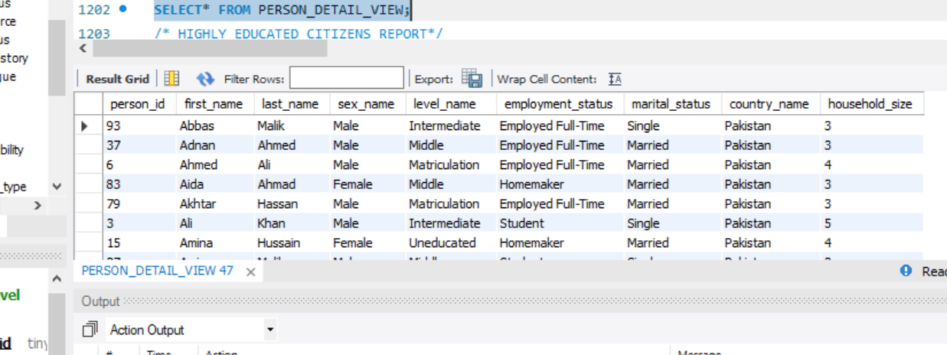
2.
CREATE VIEW Highly_Educated_Persons AS
SELECT
p.first_name,
p.last_name,
el.level_name,
es.status_name,
o.occupation_name,
i.industry_name,
p.monthly_income
FROM Person p

INNER JOIN Education_Level el
ON p.education_level_id = el.education_level_id

INNER JOIN Employment_Status es
ON p.employment_status_id = es.employment_status_id

INNER JOIN Occupation o
ON p.occupation_id = o.occupation_id

INNER JOIN Industry i
ON p.industry_id = i.industry_id
WHERE el.level_name ='BACHELORS' OR EL.LEVEL_NAME='MASTERS' OR EL.LEVEL_NAME= 'PHD';
/* VIEW */
SELECT* FROM HIGHLY_EDUCATED_PERSONS;
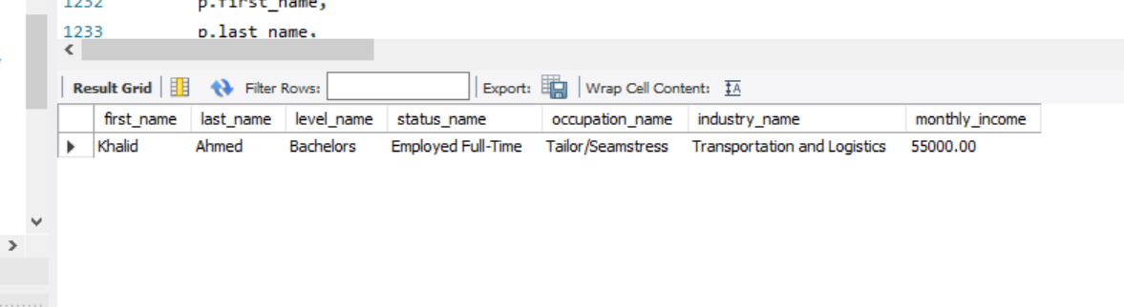

3.
CREATE VIEW MIGRATION_EDUCATION_EPLOYMENT_RECORD AS
SELECT
p.first_name,
p.last_name,
mh.migration_reason,
mh.year_of_migration,
d.district_name,
el.level_name,
es.status_name
FROM Migration_History mh

INNER JOIN Person p
ON mh.person_id = p.person_id

INNER JOIN District d
ON mh.previous_district_id = d.district_id

INNER JOIN Education_Level el
ON p.education_level_id = el.education_level_id

INNER JOIN Employment_Status es
ON p.employment_status_id = es.employment_status_id

ORDER BY mh.year_of_migration DESC;
SELECT* FROM MIGRATION_EDUCATION_EPLOYMENT_RECORD;
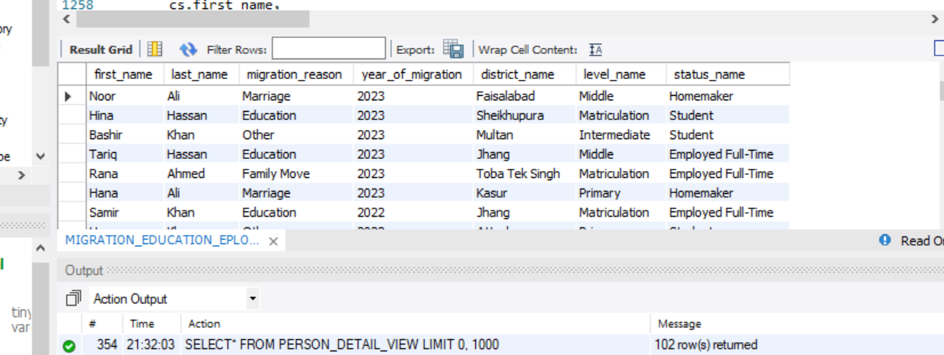

4.
CREATE VIEW STAFF_WORKING_REPORT AS
SELECT
cs.first_name,
cs.last_name,
cs.staff_role,
cb.census_block_code,
uc.union_council_name,
t.tehsil_name,
d.district_name
FROM Census_Staff cs

INNER JOIN Census_Block cb
ON cs.assigned_census_block_id = cb.census_block_id

INNER JOIN Union_Council uc
ON cb.union_council_id = uc.union_council_id

INNER JOIN Tehsil t
ON uc.tehsil_id = t.tehsil_id

INNER JOIN District d
ON t.district_id = d.district_id

ORDER BY cs.staff_role;
/* VIEW */
SELECT* FROM STAFF_WORKING_REPORT;

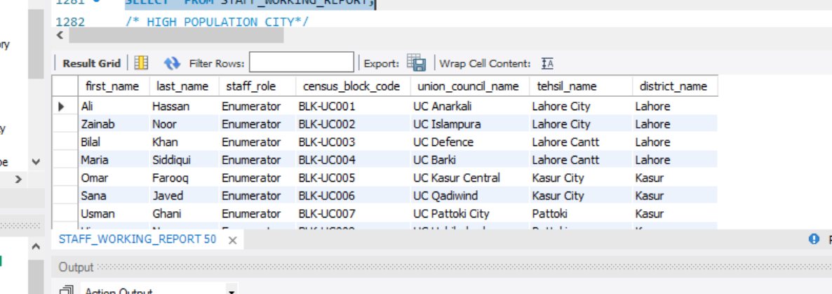

5.
CREATE VIEW TOP_POPULATION_CITIES AS
SELECT
p.province_name,
d.district_name,
SUM(cb.estimated_household_count) AS Total_Population

FROM Province p

INNER JOIN Division dv
ON p.province_id = dv.province_id

INNER JOIN District d
ON dv.division_id = d.division_id

INNER JOIN Tehsil t
ON d.district_id = t.district_id

INNER JOIN Union_Council uc
ON t.tehsil_id = uc.tehsil_id

INNER JOIN Census_Block cb
ON uc.union_council_id = cb.union_council_id

GROUP BY
p.province_name,
d.district_name

ORDER BY
Total_Population DESC

LIMIT 3;

SELECT* FROM TOP_POPULATION_CITIES;
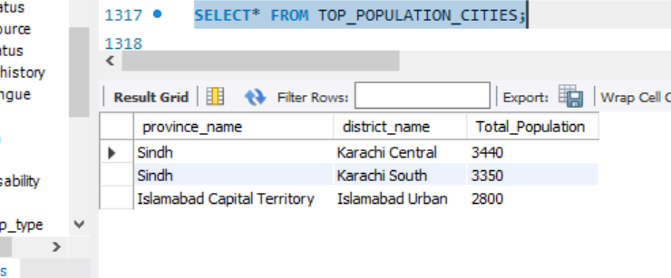

LEFT JOIN
1.
CREATE VIEW CITIZENS_RECORD AS
SELECT
p.first_name,
p.last_name,
el.level_name,
es.status_name AS employment_status,
o.occupation_name,
i.industry_name,
n.country_name

FROM Person p

LEFT JOIN Education_Level el
ON p.education_level_id = el.education_level_id

LEFT JOIN Employment_Status es
ON p.employment_status_id = es.employment_status_id

LEFT JOIN Occupation o
ON p.occupation_id = o.occupation_id

LEFT JOIN Industry i
ON p.industry_id = i.industry_id

LEFT JOIN Mother_Tongue mt
ON p.mother_tongue_id = mt.mother_tongue_id

LEFT JOIN Nationality n
ON p.nationality_id = n.nationality_id

ORDER BY el.level_name;
SELECT* FROM CITIZENS_RECORD;
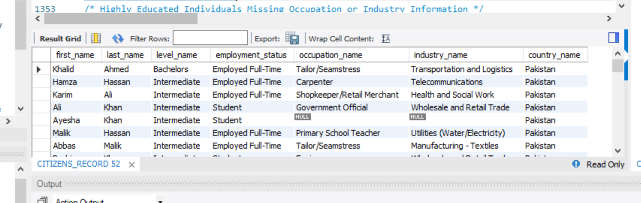
2.
CREATE VIEW HOUSEhOLD_ANALYSIS AS
SELECT
p.first_name,
p.last_name,
ms.status_name,
h.household_size

FROM Person p

LEFT JOIN Marital_Status ms
ON p.marital_status_id = ms.marital_status_id

LEFT JOIN Employment_Status es
ON p.employment_status_id = es.employment_status_id

LEFT JOIN Household h
ON p.household_id = h.household_id

WHERE ms.status_name = 'Married';
SELECT* FROM HOUSEHOLD_ANALYSIS; 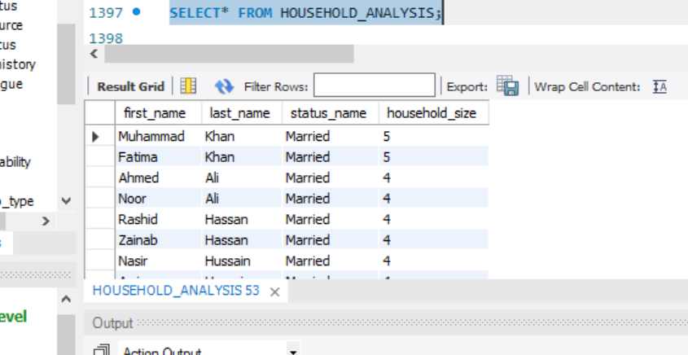

3.
CREATE VIEW MIGRATIONEDUCATED_UNEMPLOYMENT AS
SELECT
p.first_name,
p.last_name,
mh.migration_reason,
el.level_name,
es.status_name

FROM Person p

LEFT JOIN Migration_History mh
ON p.person_id = mh.person_id

LEFT JOIN Education_Level el
ON p.education_level_id = el.education_level_id

LEFT JOIN Employment_Status es
ON p.employment_status_id = es.employment_status_id

WHERE mh.person_id IS NOT NULL
AND el.level_name IN ('Bachelor','Master','MPhil')
AND es.status_name = 'Unemployed';

SELECT* FROM MIGRATIONEDUCATED_UNEMPLOYMENT;
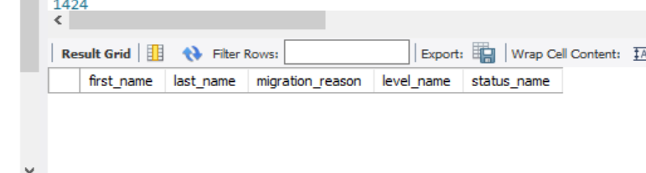

RIGHT JOIN
1.
CREATE VIEW URBAN_BLOCK_STAFF_ASSIGNMENT AS
SELECT
cs.first_name AS staff_first_name,
cs.last_name AS staff_last_name,
cs.staff_role,
cs.contact_number,
cb.census_block_code,
cb.estimated_household_count,
cb.area_sq_km,
uc.union_council_name,
t.tehsil_name,
d.district_name

FROM Census_Staff cs

RIGHT JOIN Census_Block cb
ON cs.assigned_census_block_id = cb.census_block_id

RIGHT JOIN Union_Council uc
ON cb.union_council_id = uc.union_council_id

RIGHT JOIN Tehsil t
ON uc.tehsil_id = t.tehsil_id

RIGHT JOIN District d
ON t.district_id = d.district_id

WHERE cb.is_urban = TRUE
AND cb.estimated_household_count > 300
AND cs.staff_role IN ('Enumerator', 'Supervisor')

ORDER BY cb.estimated_household_count DESC;

-- View Query:
SELECT * FROM URBAN_BLOCK_STAFF_ASSIGNMENT;

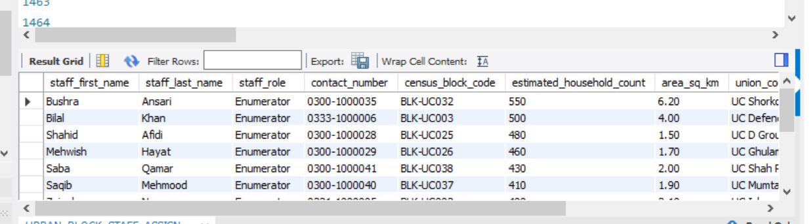

2.
CREATE VIEW MIGRANT_EMPLOYMENT_HOUSING_REPORT AS
SELECT
p.first_name,
p.last_name,
mh.migration_reason,
mh.year_of_migration,
d.district_name AS migrated_from_district,
el.level_name AS education_level,
es.status_name AS employment_status,
o.occupation_name,
p.monthly_income,
rst.status_name AS residential_status,
h.number_of_rooms,
h.household_size,
ws.source_name AS water_source,
ls.source_name AS lighting_source

FROM District d

RIGHT JOIN Migration_History mh
ON d.district_id = mh.previous_district_id

RIGHT JOIN Person p
ON mh.person_id = p.person_id

RIGHT JOIN Education_Level el
ON p.education_level_id = el.education_level_id

RIGHT JOIN Employment_Status es
ON p.employment_status_id = es.employment_status_id

RIGHT JOIN Occupation o
ON p.occupation_id = o.occupation_id

RIGHT JOIN Household h
ON p.household_id = h.household_id

RIGHT JOIN Residential_Status_Type rst
ON h.residential_status_type_id = rst.residential_status_type_id

RIGHT JOIN Structure s
ON h.structure_id = s.structure_id

RIGHT JOIN Water_Source ws
ON s.water_source_id = ws.water_source_id

RIGHT JOIN Lighting_Source ls
ON s.lighting_source_id = ls.lighting_source_id

WHERE mh.year_of_migration BETWEEN 2015 AND 2023
AND es.status_name IN (
'Employed Full-Time',
'Employed Part-Time',
'Self-Employed'
)
AND h.household_size >= 3

ORDER BY mh.year_of_migration DESC,
p.monthly_income DESC;

-- View Query:
SELECT * FROM MIGRANT_EMPLOYMENT_HOUSING_REPORT;
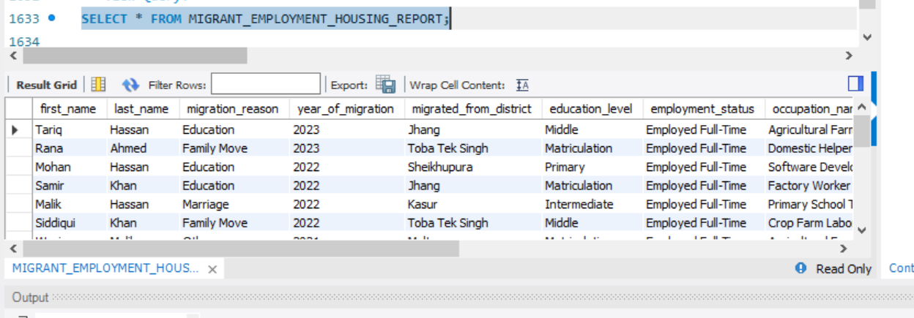

3.
CREATE VIEW DISABLEDUNEMPLOYED_LOCATION_REPORT AS
SELECT
dt.disability_name,
p.first_name,
p.last_name,
p.date_of_birth,
bs.sex_name AS gender,
es.status_name AS employment_status,
el.level_name AS education_level,
p.monthly_income,
d.district_name,
pr.province_name

FROM Disability_Type dt

RIGHT JOIN Person_Disability pd
ON dt.disability_type_id = pd.disability_type_id

RIGHT JOIN Person p
ON pd.person_id = p.person_id

RIGHT JOIN Biological_Sex bs
ON p.sex_id = bs.sex_id

RIGHT JOIN Employment_Status es
ON p.employment_status_id = es.employment_status_id

RIGHT JOIN Education_Level el
ON p.education_level_id = el.education_level_id

RIGHT JOIN Household h
ON p.household_id = h.household_id

RIGHT JOIN Structure s
ON h.structure_id = s.structure_id

RIGHT JOIN Census_Block cb
ON s.census_block_id = cb.census_block_id

RIGHT JOIN Union_Council uc
ON cb.union_council_id = uc.union_council_id

RIGHT JOIN Tehsil t
ON uc.tehsil_id = t.tehsil_id

RIGHT JOIN District d
ON t.district_id = d.district_id

RIGHT JOIN Division dv
ON d.division_id = dv.division_id

RIGHT JOIN Province pr
ON dv.province_id = pr.province_id

WHERE es.status_name IN (
'Unemployed - Seeking Work',
'Unemployed - Not Seeking Work',
'Disabled - Unable to Work'
)
AND p.monthly_income IS NULL

ORDER BY dt.disability_name,
pr.province_name;

-- View Query:
SELECT * FROM DISABLEDUNEMPLOYED_LOCATION_REPORT;

FULL OUTER JOIN
1.
CREATE VIEW FULL_PERSON_DISABILITY_REPORT AS

SELECT
p.first_name,
p.last_name,
p.date_of_birth,
bs.sex_name AS gender,
dt.disability_name,
el.level_name AS education_level,
es.status_name AS employment_status

FROM Person p

LEFT JOIN Person_Disability pd
ON p.person_id = pd.person_id

LEFT JOIN Disability_Type dt
ON pd.disability_type_id = dt.disability_type_id

LEFT JOIN Biological_Sex bs
ON p.sex_id = bs.sex_id

LEFT JOIN Education_Level el
ON p.education_level_id = el.education_level_id

LEFT JOIN Employment_Status es
ON p.employment_status_id = es.employment_status_id

WHERE es.status_name = 'Employed Full-Time'
AND el.level_name IN ('Bachelors', 'Masters')

UNION

SELECT
p.first_name,
p.last_name,
p.date_of_birth,
bs.sex_name AS gender,
dt.disability_name,
el.level_name AS education_level,
es.status_name AS employment_status

FROM Person p

RIGHT JOIN Person_Disability pd
ON p.person_id = pd.person_id

RIGHT JOIN Disability_Type dt
ON pd.disability_type_id = dt.disability_type_id

RIGHT JOIN Biological_Sex bs
ON p.sex_id = bs.sex_id

RIGHT JOIN Education_Level el
ON p.education_level_id = el.education_level_id

RIGHT JOIN Employment_Status es
ON p.employment_status_id = es.employment_status_id

WHERE es.status_name = 'Employed Full-Time'
AND el.level_name IN ('Bachelors', 'Masters')

ORDER BY disability_name, last_name;

-- View Query:
SELECT * FROM FULL_PERSON_DISABILITY_REPORT;

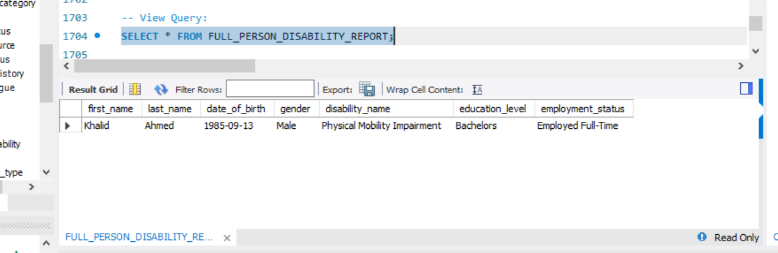

2.
CREATE VIEW FULL_HOUSEHOLD_STRUCTURE_REPORT AS

SELECT
h.household_id,
h.household_size,
h.number_of_rooms,
rst.status_name AS residential_status,
s.structure_address_no,
st.type_name AS structure_type,
ws.source_name AS water_source

FROM Household h

LEFT JOIN Structure s
ON h.structure_id = s.structure_id

LEFT JOIN Residential_Status_Type rst
ON h.residential_status_type_id = rst.residential_status_type_id

LEFT JOIN Structure_Type st
ON s.structure_type_id = st.structure_type_id

LEFT JOIN Water_Source ws
ON s.water_source_id = ws.water_source_id

WHERE h.household_size > 2
AND rst.status_name IN ('Owned', 'Rented')

UNION

SELECT
h.household_id,
h.household_size,
h.number_of_rooms,
rst.status_name AS residential_status,
s.structure_address_no,
st.type_name AS structure_type,
ws.source_name AS water_source

FROM Household h

RIGHT JOIN Structure s
ON h.structure_id = s.structure_id

RIGHT JOIN Residential_Status_Type rst
ON h.residential_status_type_id = rst.residential_status_type_id

RIGHT JOIN Structure_Type st
ON s.structure_type_id = st.structure_type_id

RIGHT JOIN Water_Source ws
ON s.water_source_id = ws.water_source_id

WHERE h.household_size > 2
AND rst.status_name IN ('Owned', 'Rented')

ORDER BY household_size DESC;

-- View Query:
SELECT * FROM FULL_HOUSEHOLD_STRUCTURE_REPORT;
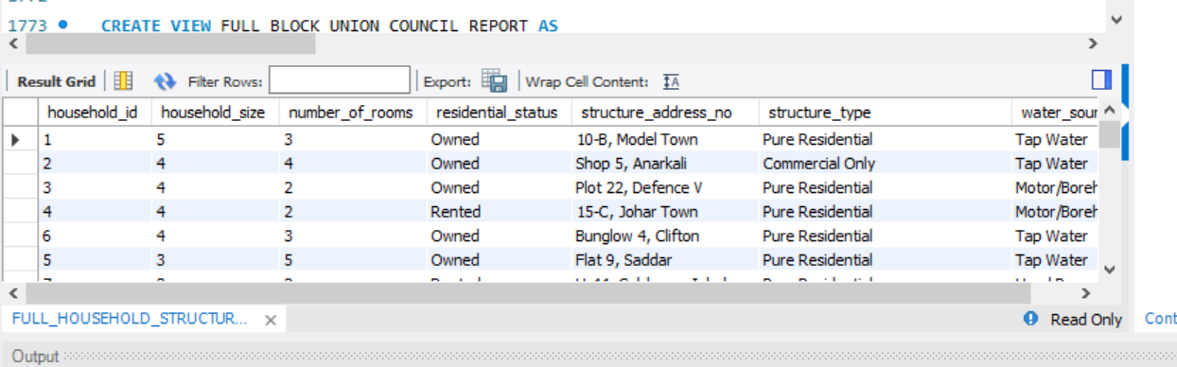

3.
CREATE VIEW FULL_BLOCK_UNION_COUNCIL_REPORT AS

SELECT
cb.census_block_code,
cb.estimated_household_count,
cb.is_urban,
cb.area_sq_km,
uc.union_council_name,
ucc.classification_name,
t.tehsil_name

FROM Census_Block cb

LEFT JOIN Union_Council uc
ON cb.union_council_id = uc.union_council_id

LEFT JOIN Union_Council_Classification ucc
ON uc.union_council_classification_id = ucc.union_council_classification_id

LEFT JOIN Tehsil t
ON uc.tehsil_id = t.tehsil_id

WHERE cb.estimated_household_count > 200
AND cb.is_urban = TRUE

UNION

SELECT
cb.census_block_code,
cb.estimated_household_count,
cb.is_urban,
cb.area_sq_km,
uc.union_council_name,
ucc.classification_name,
t.tehsil_name

FROM Census_Block cb

RIGHT JOIN Union_Council uc
ON cb.union_council_id = uc.union_council_id

RIGHT JOIN Union_Council_Classification ucc
ON uc.union_council_classification_id = ucc.union_council_classification_id

RIGHT JOIN Tehsil t
ON uc.tehsil_id = t.tehsil_id

WHERE cb.estimated_household_count > 200
AND cb.is_urban = TRUE

ORDER BY estimated_household_count DESC;

-- View Query:
SELECT * FROM FULL_BLOCK_UNION_COUNCIL_REPORT;
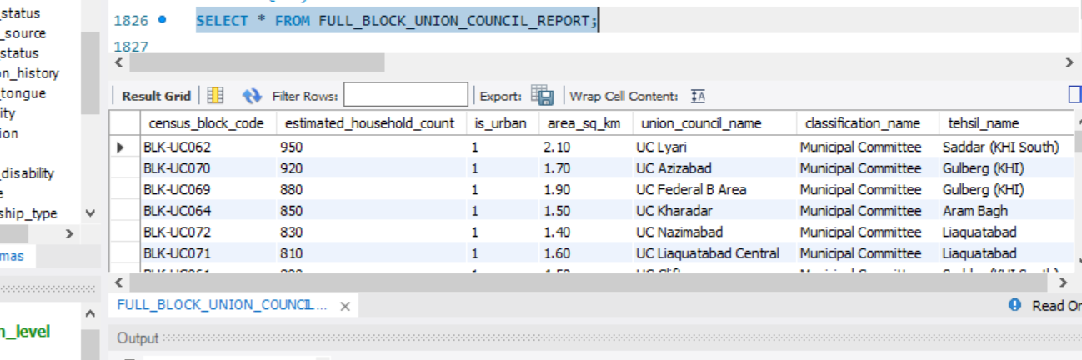

4.
CREATE VIEW FULL_COMMERCIAL_PROVINCE_REPORT AS

SELECT
sc.business_name,
sc.estimated_active_employees,
sc.has_active_license,
cst.commercial_type_name,
s.structure_address_no,
d.district_name,
pr.province_name

FROM Structure_Commercial sc

LEFT JOIN Commercial_Sector_Type cst
ON sc.commercial_type_id = cst.commercial_type_id

LEFT JOIN Structure s
ON sc.structure_id = s.structure_id

LEFT JOIN Census_Block cb
ON s.census_block_id = cb.census_block_id

LEFT JOIN Union_Council uc
ON cb.union_council_id = uc.union_council_id

LEFT JOIN Tehsil t
ON uc.tehsil_id = t.tehsil_id

LEFT JOIN District d
ON t.district_id = d.district_id

LEFT JOIN Division dv
ON d.division_id = dv.division_id

LEFT JOIN Province pr
ON dv.province_id = pr.province_id

WHERE sc.has_active_license = TRUE
AND sc.estimated_active_employees > 5

UNION

SELECT
sc.business_name,
sc.estimated_active_employees,
sc.has_active_license,
cst.commercial_type_name,
s.structure_address_no,
d.district_name,
pr.province_name

FROM Structure_Commercial sc

RIGHT JOIN Commercial_Sector_Type cst
ON sc.commercial_type_id = cst.commercial_type_id

RIGHT JOIN Structure s
ON sc.structure_id = s.structure_id

RIGHT JOIN Census_Block cb
ON s.census_block_id = cb.census_block_id

RIGHT JOIN Union_Council uc
ON cb.union_council_id = uc.union_council_id

RIGHT JOIN Tehsil t
ON uc.tehsil_id = t.tehsil_id

RIGHT JOIN District d
ON t.district_id = d.district_id

RIGHT JOIN Division dv
ON d.division_id = dv.division_id

RIGHT JOIN Province pr
ON dv.province_id = pr.province_id

WHERE sc.has_active_license = TRUE
AND sc.estimated_active_employees > 5

ORDER BY estimated_active_employees DESC;
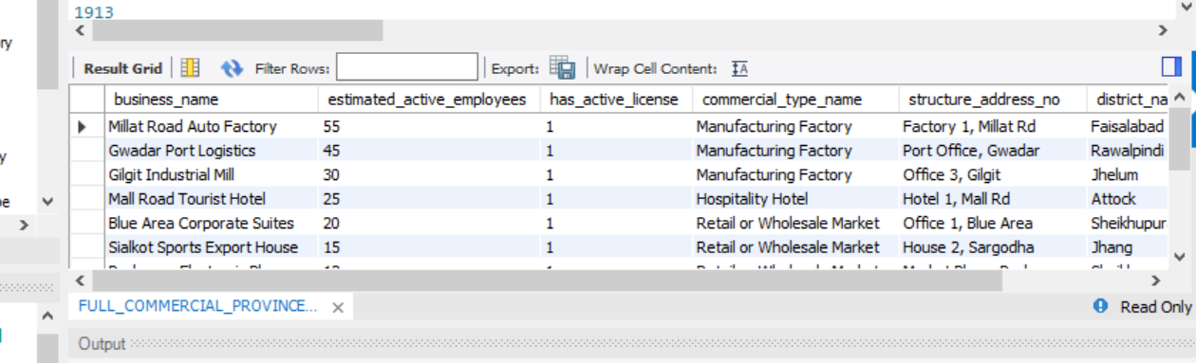

NATURAL JOIN
1.
CREATE VIEW NATURAL_PERSON_MARITAL_REPORT AS

SELECT
p.first_name,
p.last_name,
p.date_of_birth,
p.monthly_income,
ms.status_name

FROM Marital_Status ms

NATURAL JOIN (
SELECT
marital_status_id,
first_name,
last_name,
date_of_birth,
monthly_income
FROM Person
) p
WHERE ms.status_name = 'Married'
AND p.monthly_income > 20000
ORDER BY p.monthly_income DESC;
-- View Query:
SELECT * FROM NATURAL_PERSON_MARITAL_REPORT;

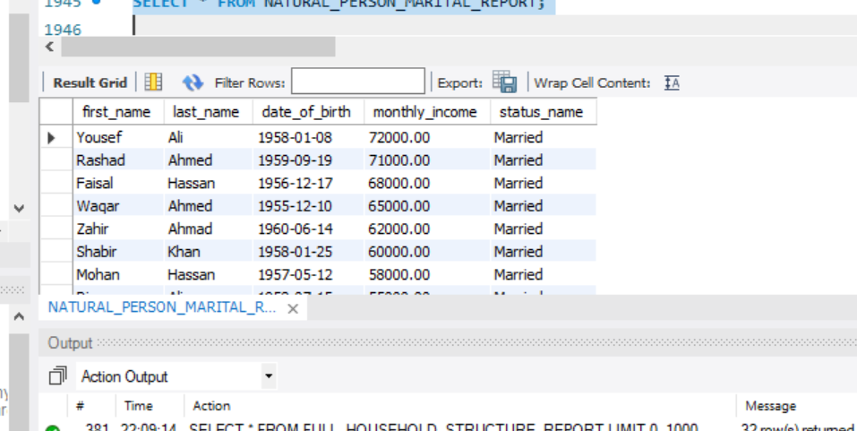
2.
CREATE VIEW NATURAL_PERSON_EDUCATION_REPORT AS

SELECT
p.first_name,
p.last_name,
p.monthly_income,
p.date_of_birth,
el.level_name

FROM Education_Level el

NATURAL JOIN (
SELECT
education_level_id,
first_name,
last_name,
monthly_income,
date_of_birth
FROM Person
) p

WHERE el.level_name IN (
'Bachelors',
'Masters',
'Doctorate'
)
AND p.monthly_income > 25000

ORDER BY el.level_name, p.monthly_income DESC;

-- View Query:
SELECT * FROM NATURAL_PERSON_EDUCATION_REPORT;
